Allowance Tracker App

(*Student Allowance Tracker*)

Project Documentation Submitted to the Faculty of the

School of Computing and Information Technologies

Asia Pacific College

In Partial Fulfillment of the Requirements for

SHS Bootcamp

By

Leonard Delos Reyes

Alexander Troy Dumawal

Anton Luis B. Galido

J. Andrew Quintua

Table of Contents

Executive Summary 2

Introduction 6

Project Context 7

Statement of the Problem 8

Objectives 8

Significance of the Project 9

Scope and Limitations 10

II. 11

Review of Related Literature / Systems 11

Technical Background 13

Current System 14

Proposed System 14

Conclusion 14

References 15

Appendices 16

Appendix A: Story Board Design Thinking 17

Appendix B: Schedule 17

Appendix C: Problem Rundown 18

Appendix D: Design Thinking Empathy Map 19

Appendix E: Team Meetings 21

Appendix F: Ideation and Prioritization Grid 22

Appendix G: As Is Map Design Thinking 24

Appendix H: Need Statement 24

Appendix I: Contributions 24

# Executive Summary

Managing allowances effectively is a significant challenge for students, often leading to financial stress and poor money management habits. The Student Allowance Tracker App is designed to simplify and enhance the financial management experience for students, providing a comprehensive toolset to track expenses, manage savings, and improve financial literacy.

Students need intuitive and effective tools to help them manage their finances. Traditional methods of budgeting and expense tracking can be cumbersome and inefficient. There is a growing need for a user-friendly application that addresses these challenges and supports students in developing responsible financial habits.

The Student Allowance Tracker App provides a robust platform with several key features designed to meet the specific needs of students:

The Login Page offers a secure, hard-coded login, ensuring a safe entry point for users. This foundational feature guarantees that each user's financial data is protected from unauthorized access.

Upon logging in, users are greeted by the Homepage, which features a clean and intuitive text view layout. This page serves as the central hub of the app, displaying an overview of the user’s financial activities and quick access to various functionalities.

The Tracker History feature allows users to input detailed financial information, such as the days tracked, money spent, savings accumulated, daily money input, and the mode of payment used. This data is meticulously stored in Firebase, providing a reliable and accessible database that users can refer to anytime. This comprehensive tracking system ensures that students have a clear and organized record of their financial activities.

To assist with daily financial management, the app includes an Expense Calculator. This tool calculates the amount of money spent each day and subtracts it from the user’s daily allowance. This real-time calculation provides students with immediate feedback on their spending, helping them to adjust their habits accordingly and avoid overspending.

Adding expenses can be more convenient with the Data Input Icon. Located on the homepage, this feature allows for quick and easy input of daily expenses. The user-friendly design ensures that students can promptly update their financial records without any hassle, maintaining accurate and up-to-date tracking.

A notable feature of the app is the AI Assistant Chatbot, which utilizes the ChatGPT API. This chatbot provides personalized financial tips and guidance, helping students make informed decisions about their spending and savings. Accessible through an icon on the homepage, the chatbot requires internet access and supports English language interactions. This feature not only enhances the user experience but also serves as an educational tool, promoting better financial literacy.

The integration with Firebase ensures that users' data is securely stored and easily retrievable. The AI assistant chatbot adds a level of convenience by offering personalized financial advice, enhancing the user experience and supporting better financial decision-making.

# Introduction

An allowance tracker is a valuable tool for monitoring and managing everyday spending patterns. Financial literacy, financial knowledge, and financial education are often used interchangeably in academic literature and popular media. Although defined differently by various sources, they all revolve around the usage and understanding of money. In the Philippines, spending typically takes precedence over saving when people receive their salaries. Allowance tracking helps individuals develop responsibility for their finances and stay on top of their financial objectives.

However, the Philippines faces significant challenges with financial literacy. The World Bank found that only 25% of adult Filipinos are knowledgeable about basic financial concepts. In a global study by Standard & Poor’s (S&P Global Ratings), the Philippines ranked in the bottom 30 of 144 countries surveyed on financial literacy (Bangko Sentral Ng Pilipinas Media and Research - Speeches, 2022). This lack of financial knowledge leads to difficulties in managing finances, preparing for emergencies, and achieving financial goals.

## Project Context

As a Filipino student, we often hear the term 'financial literacy' mentioned in various conversations, especially when discussing personal finance, economics, or even career planning. If you aren't aware of what it means, financial literacy is the capacity to comprehend and apply different kinds of financial skills. These skills are essential for making informed and effective decisions about money. One such ability is investing, which is putting money into securities such as stocks, bonds, or real estate with the hope of making a profit over time. Students who grasp the fundamentals of investing can increase their wealth and make long-term financial plans. Another essential part of financial literacy is budgeting. It entails making a budget and making sure you can save money for future requirements while still paying for necessities like books, living expenses, and tuition. Students who budget well can avoid needless debt and handle their money more skillfully. A wider variety of abilities are included in personal financial management, such as goal setting. It entails taking deliberate action to preserve or improve one's financial health and being aware of one's financial condition.

According to a global study from Philippine News Agency (PNA), the Philippines is in the bottom 30 out of 144 countries in terms of financial literacy. The Bangko Sentral ng Pinas (BSP) surveyed Filipino adults about it. And yet only 1 percent of them got the correct answer. Many students rely on allowances and face irregular financial support, making budgeting and financial planning difficult. Students often struggle with managing their limited resources, leading to challenges in saving, budgeting, and avoiding debt.

## Statement of the Problem

Expense tracking can pose significant challenges for students and individuals with allowances or irregular incomes (Johnson, 2023). These difficulties often stem from irregular expenses, the complexity of managing information across multiple accounts, and tendencies towards procrastination in tracking transactions (Johnson, 2023). Balancing fluctuating income with varying expenses can create additional hurdles in maintaining accurate financial records and staying within budget. One of the most frequent issues facing those students who want to manage their money sensibly is keeping track of their spending. Many students find it difficult to control their spending, which can lead to overspending, a failure to save money, or difficulties reaching their financial objectives. One technological tool that can help students monitor and manage their finances better is an allowance tracker.

## Objectives

**Main Objective**

To improve Financial Literacy among students by providing a user-friendly allowance tracker program that aids the users in managing their allowances and expenses.

**Specific Objectives**

1. Develop a comprehensive tracking system for the users

* Specific: Create a tracking system within the program that allows students to log their daily expenses and categorize them accurately.
* Measurable: Ensure the tracking system can log and categorize expenses with an intuitive user interface
* Achievable: Utilize existing financial tracking technologies and adapt them for student use.
* Realistic: Leverage a team of developers and financial experts to design and test the system.
* Time-bound: Complete the development and initial testing phase as per the project timeline provided by the instructors.

1. Visualizing with Graphs and Charts

* Specific: Allow students to view their spending data through graphs and charts.
* Measurable: Ensure the graphing feature can display spending data visually with at least three different chart types (e.g., bar charts, pie charts, line graphs).
* Achievable: Use basic graphing libraries to visualize spending data.
* Realistic: Start with simple visualizations that can be easily implemented and expanded upon later.
* Time-bound: Develop and integrate the graphing feature within the project timeline.

1. Integrate an AI Assistant for Financial Guidance

* Specific: Develop a help and support feature within the program to provide users with guidance on using the app and basic financial tips.
* Measurable: Ensure the help feature is comprehensive and accessible, addressing common user questions and issues.
* Achievable: Utilize available resources and programming skills to create a user-friendly help section.
* Realistic: Focus on creating clear and helpful content that is appropriate for student users.
* Time-bound: Integrate the help and support feature within the project timeline and ensure it is easily accessible to users.

## Significance of the Project

The Student Allowance Tracker App aims to provide a user-friendly solution for tracking expenses, categorizing spending, and gaining insights into financial habits. Inspired by the growing need for financial literacy from a young age, the Student Allowance Tracker App was designed to be a user-friendly solution. By incorporating features for expense tracking, spending categorization, and financial data visualization, the app empowers users to develop responsible money management habits.

To efficiently manage their allowance and keep track of their spending, students will benefit from using a Student Allowance Tracker. The system we created for this project enables users to enter track their expenditure over time, categorize them, and manage their allowance.

An SDG like Responsible Consumption and Production focuses on reducing our environmental footprint and changing consumption habits. The Student Allowance Tracker App can contribute by:

* **Encouraging students to budget**: By tracking expenses, students become aware of where their money goes. This awareness can lead to cutting unnecessary spending and prioritizing needs over wants.
* **Promoting mindful purchases**: Features like category tracking can help students see how much they spend on specific items, potentially leading to more sustainable choices.

## Scope and Limitations

Encouraging students to handle their money well is the main goal of a student allowance tracker app. Through features like category analysis, budgeting tools, and expense tracking, it aims to encourage responsible spending habits. Making well-informed decisions can result in cutting back on wasteful expenditure and setting demands in order of importance. The software can also encourage students to live more sustainably by promoting thoughtful shopping and goal setting for eco-friendly purchases. However, the app's emphasis on managing personal finances is one of its drawbacks. External elements like revenue and unforeseen expenses are outside its immediate control. Since the software depends on user input, students must be dedicated to accurate tracking and budgetary compliance for it to be effective.

However, the app has limits. It relies significantly on user input for accurate tracking; therefore, its usefulness is dependent on the regularity and honesty of the user's entries. The app may not work with all banking institutions, which limits automatic transaction updates. The sensitive nature of the financial data being maintained may raise privacy concerns. Furthermore, the software may be less effective for students with unpredictable income or spending patterns because it does not account for variability well. Finally, the app's usefulness may suffer if it lacks features that address the specific financial difficulties that students encounter, such as managing student loans or accessing financial aid options.

Student allowance tracker software has features that assist students manage their resources successfully. The software allows users to register their revenue sources, such as allowances from parents or part-time job earnings, and track their expenditure in areas such as food, transportation, entertainment, and school supplies. It includes tools like budgeting, expense categorization, and graphs and charts to visually illustrate spending patterns. The software attempts to foster financial discipline in students by delivering budget reminders and money-saving recommendations.

Another notable feature of the app is an AI assistant chatbot, designed to offer financial guidance and support. However, this assistant cannot access users' personal data, which means its tips and suggestions are not personalized specifically to the user. While it provides general tips and answers to common questions, the lack of data access may limit its ability to offer tailored recommendations based on individual spending habits and financial situations.

# II.

# Review of Related Literature / Systems

This chapter provides a comprehensive review of literature and systems related to financial literacy and expense tracking, focusing on how these elements are essential for improving financial management among students. The goal is to synthesize existing knowledge and technologies to identify gaps and inform the development of an effective student allowance tracker app.

Financial Literacy and Education

The importance of financial literacy is well-documented, as it plays a crucial role in effective personal finance management. According to the World Bank, only 25% of adult Filipinos are knowledgeable about basic financial concepts. This lack of financial knowledge significantly impacts their ability to manage finances, prepare for emergencies, and achieve financial goals (Bangko Sentral ng Pilipinas, 2022). Standard & Poor’s (S&P Global Ratings) global study also highlights the Philippines’ low ranking in financial literacy, placing it in the bottom 30 out of 144 countries.

In the Philippines, the lack of financial literacy among adults is a significant concern as it impacts students who often rely on allowances and face irregular financial support, making budgeting and financial planning challenging (Bangko Sentral ng Pilipinas, 2022).

Expense Tracking Systems

Expense tracking systems are essential tools for managing finances effectively. Popular applications such as Mint, YNAB (You Need A Budget), and PocketGuard offer comprehensive solutions for budget tracking, expense categorization, and financial planning (Johnson, 2023). These apps typically feature user-friendly interfaces, real-time expense tracking, and integration with bank accounts for automated transaction updates. D

For instance, Mint allows users to track expenses, set budgets, and categorize spending, providing alerts when they approach their budget limits. YNAB emphasizes proactive budgeting, encouraging users to allocate every dollar to a specific purpose, while PocketGuard simplifies expense tracking by automatically categorizing transactions and showing users their disposable income after accounting for bills and savings goals.

Combining Features for Effective Financial Management

Integrating features from existing systems can enhance the effectiveness of a student allowance tracker app. Essential components such as expense categorization, budget setting, and visualizations like graphs and charts help users understand their spending habits. Visual representations of financial data can significantly improve financial decision-making and awareness (Johnson, 2023). Additionally, incorporating an AI assistant chatbot for financial guidance can provide convenience in support, addressing common financial challenges faced by students.

Summary and Implications for the Project

The reviewed literature and systems highlight the importance of financial literacy and the effectiveness of various expense tracking features. For the Student Allowance Tracker App, integrating comprehensive tracking, visualization tools, and an AI assistant can be crucial. These elements will help students in developing responsible money management habits, improve their financial literacy, and ultimately achieve their financial goals.

By leveraging insights from existing studies and systems, the project aims to create a user-friendly and effective tool tailored to the specific financial challenges faced by students in the Philippines. This approach will address the gaps identified in the literature, providing a valuable resource for enhancing financial literacy and management skills among students.

# Technical Background

This section offers a thorough rundown of the systems and technologies used in the creation and execution of the Student Allowance Tracker. It goes through the drawbacks of the current method as well as the suggested improvements that take advantage of modern technology to boost user experience and spending tracking accuracy. Critical components needed for the current and planned systems include network infrastructure, hardware, software, and human resources.

## Current System

The existing system does not use the smart concept which is used nowadays. In existing, we need to maintain the Excel sheets, CSV files, or physical logs to track the user’s expenses. In existing, there is no such complete solution to keep track of its daily allowance expenditure easily. In the absence of an integrated solution, users are forced to handle all computations and record-keeping on their own, which frequently results in mistakes and inefficiencies in financial management. (Kapuriya, n.d.)

## Proposed System

The Student Allowance Tracker project will keep track of the user’s allowance. The application’s main objective is to track where the user’s allowance goes. The application will set goals for the user to help them manage their allotment more effectively rather than wasting it frequently. There are graphs and charts that will show the user where their allowance goes. The system allows users to enter and categorize their spending. The user’s data is secured, protecting their personal information. One of the proposed system’s distinctive features is the inclusion of an AI chatbot on the app, which students may utilize to inquire about financial objectives and spending habits. There is an intelligent budgeting system that will be implemented on the app that analyzes spending patterns and suggests budget adjustments to help students manage their allowances.

# Conclusion

This research project aims to address the issues regarding the lack of financial literacy in the Philippines and the struggles that students face when calculating and assessing their allowances or expenses. The Student Allowance Tracker app’s main objective is to support users in managing their finances more effectively by providing a user-friendly platform for tracking expenses, categorizing and accommodating in responsible spending, and visualizing financial data.

By leveraging existing financial tracking technologies and adapting them to meet the specific needs of students, the app aims to foster responsible money management habits. This can help students avoid overspending, save money, and achieve their short or even long-term financial goals. Features like expense categorization, budget setting, and visual tools such as graphs and charts will help students to understand their spending habits better and make informed financial decisions.

Moreover, the inclusion of an AI assistant for financial guidance offers users personalized tips and support, addressing common financial challenges. This assistant can provide valuable insights and advice, helping students develop better financial literacy and management skills. The significance of this project extends beyond individual financial management. By promoting responsible and mindful spending, the app attempts to contribute to broader economic stability and sustainability.

In conclusion, the Student Allowance Tracker app is a practical tool designed to enhance financial literacy and management among students. By addressing the specific financial challenges they face, this app has the potential to make a meaningful impact on their financial well-being and overall responsibility.

## Recommendations

The researchers would like to recommend the following for future development and enhancement of the application.

1. The researchers recommend adding charts and graphs for the visualization of the user’s data.
2. It is recommended to add the ability of the AI chat bot to access the user’s personal data to provide more personalized tips and guides for the user.
3. It would be preferable if the AI chat bot could analyze the user’s expenses to give recommendations for better financial goals.
4. The researchers recommend streamlining the user interface with clearly distinct areas and features, to prevent a confusing user experience and to improve ease of use.

# References

*Bangko Sentral ng Pilipinas Media and Research - Speeches*. (2022, November 21).

<https://www.bsp.gov.ph/SitePages/MediaAndResearch/SpeechesDisp.aspx?ItemId=993>

Kapuriya, P. (n.d.). *PROJECT FILE MAIN*. Scribd. <https://www.scribd.com/document/516986376/PROJECT-FILE-MAIN?fbclid=IwZXh0bgNhZW0CMTAAAR2w9l4MSCht85Dhe0ICzOnuvEw_Ju6_2PmROeao0hPY9EXC6j8Is9eX1MI_aem_AdELq6h26EqcNAwlw1mmYGe-yNRlOJ1Ll7fNtbHxYXCHRTe94onwKRrAe92XkgHlY796GehC78P2f3_VpiJ0z5Q1>

Mburugu, F. (2023, September 19). *Expense Tracker Project*. <https://www.linkedin.com/pulse/expense-tracker-project-frankline-mburugu/>

Johnson, S. (2023, October 23). *Difficulty in expense tracking.* <https://www.linkedin.com/pulse/difficulty-expense-tracking-shawna-johnson-x5oue/>

# Appendices

## Appendix A: Story Board Design Thinking

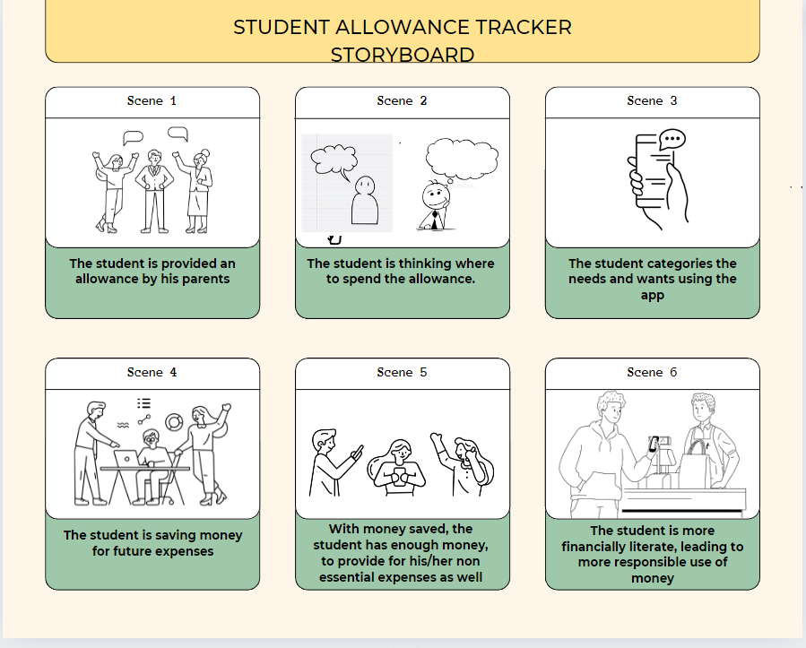

## Appendix B: Schedule

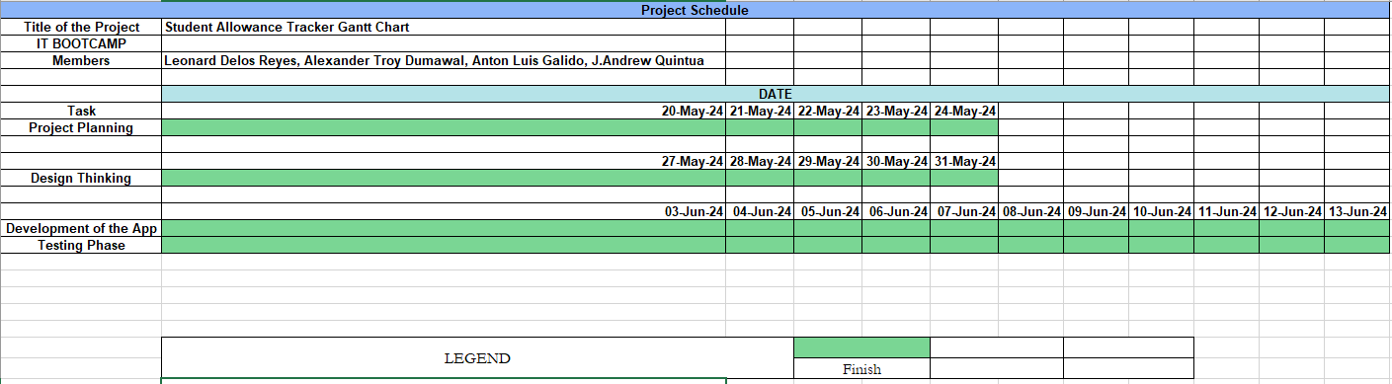

## Appendix C: Problem Rundown

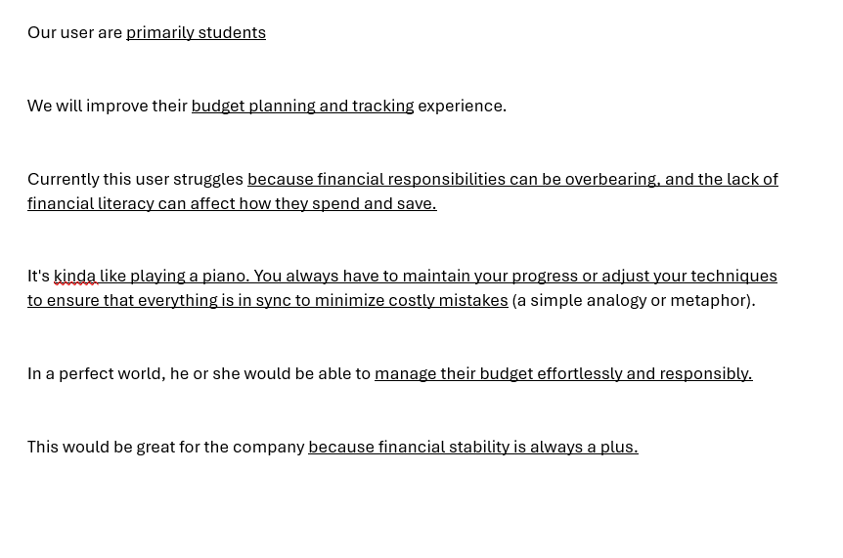

## Appendix D: Design Thinking Empathy Map

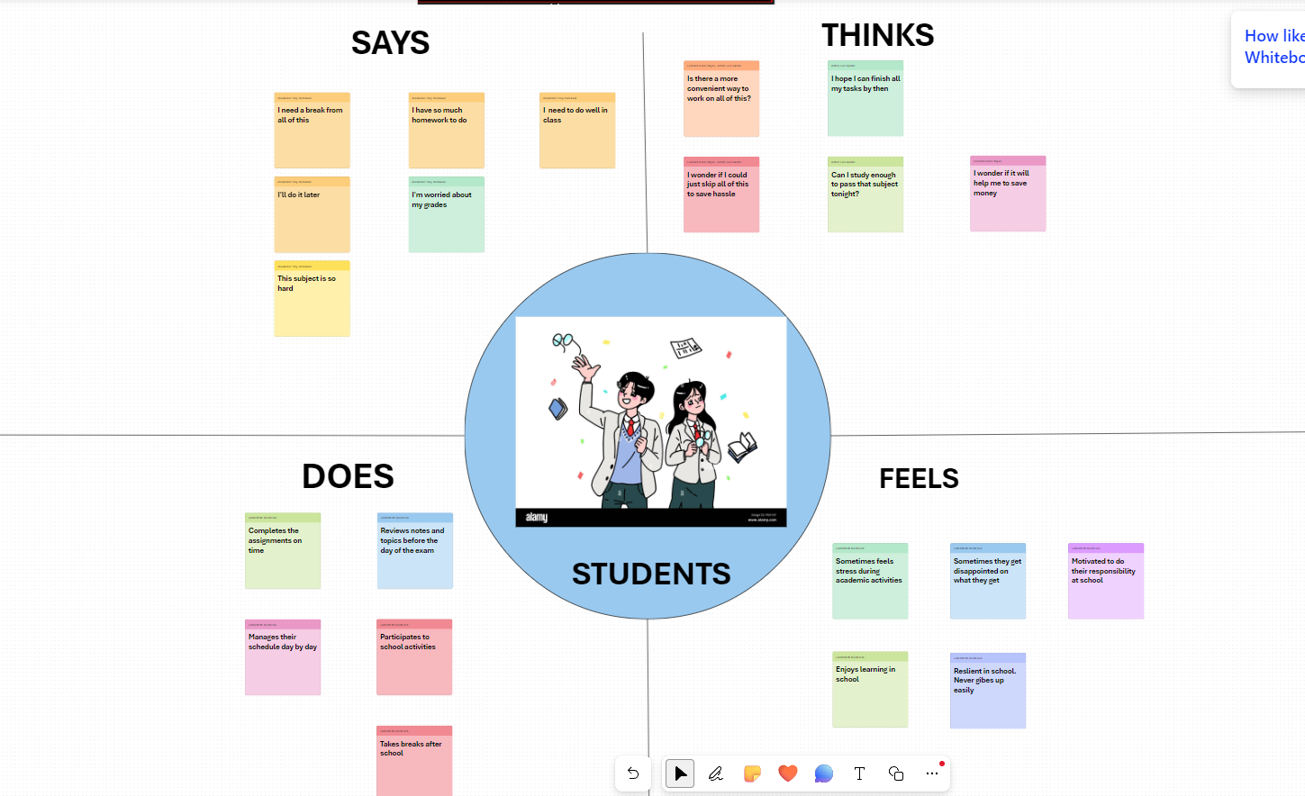

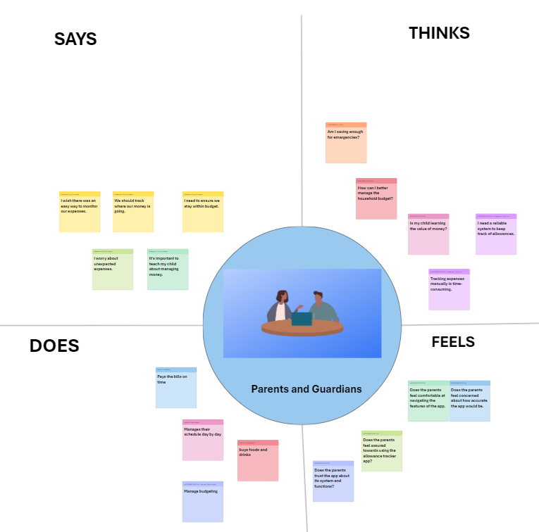

## Appendix E: Team Meetings

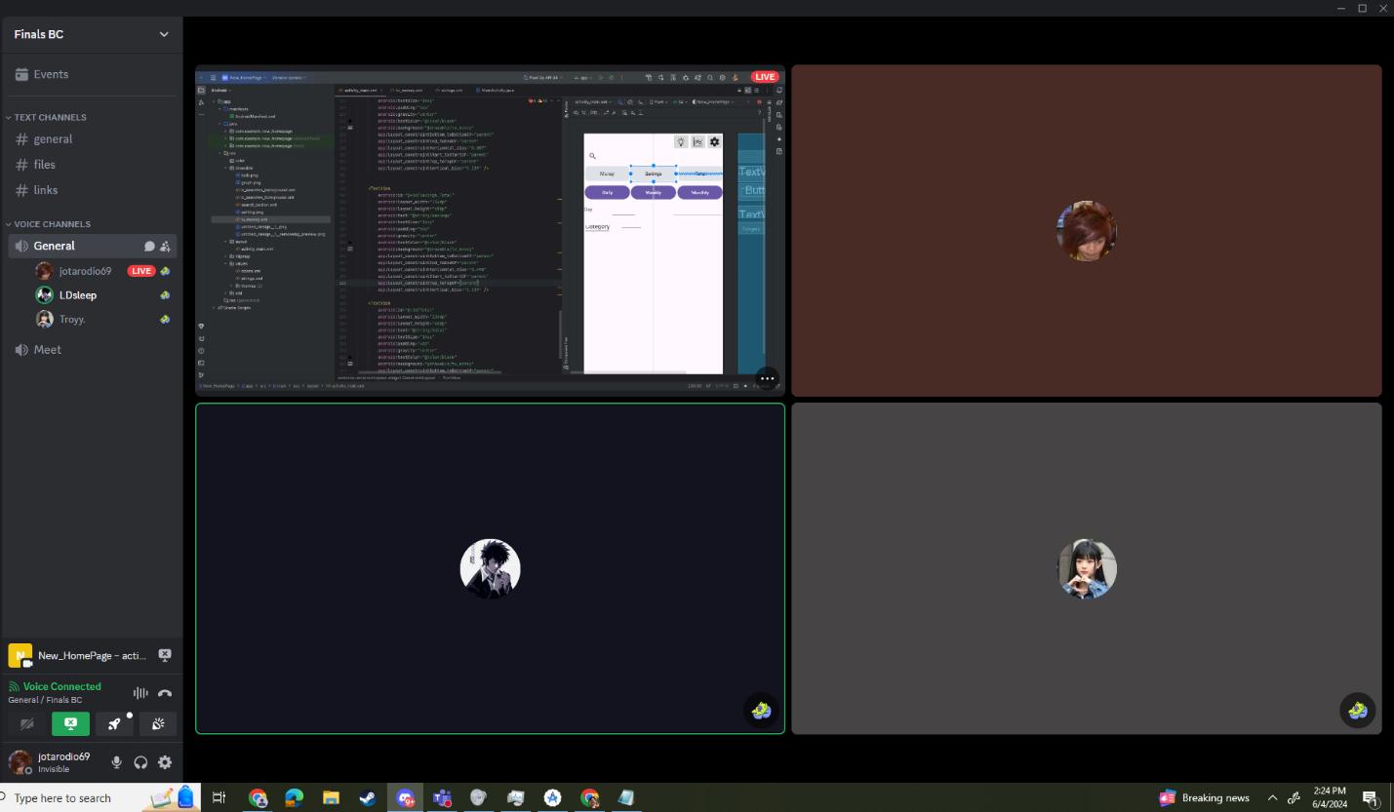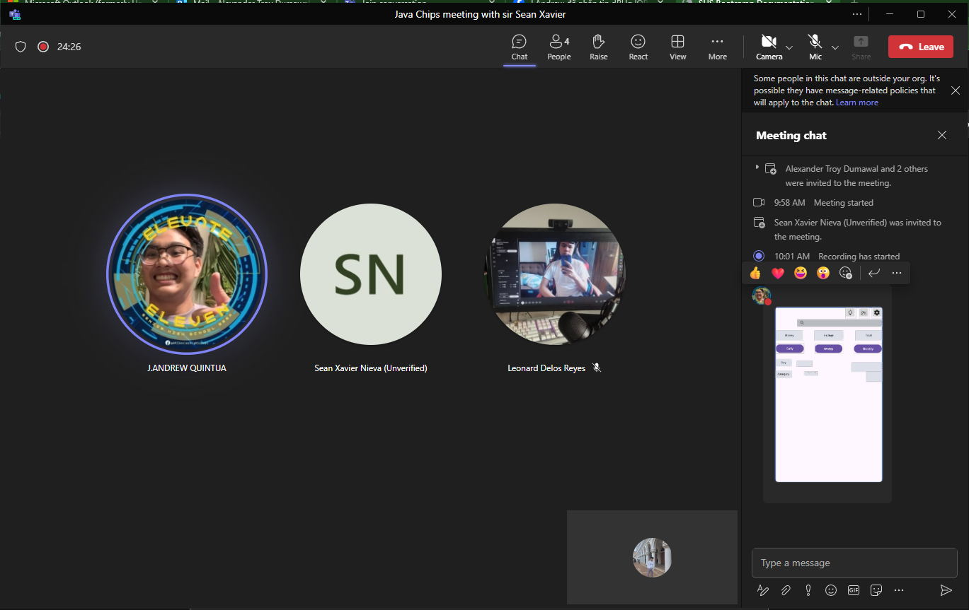

## Appendix F: Ideation and Prioritization Grid

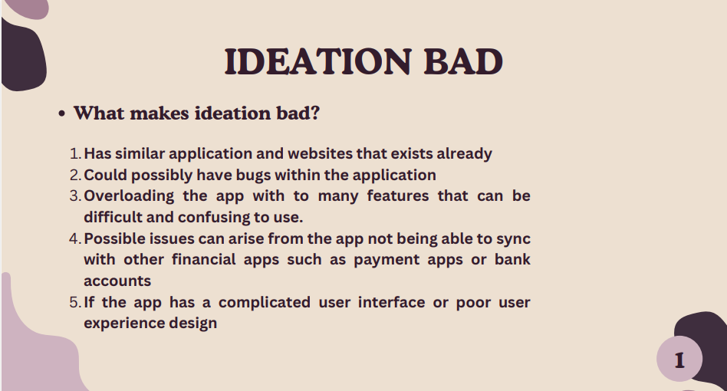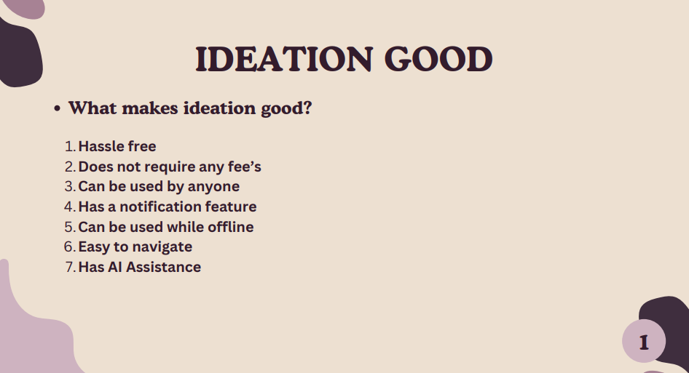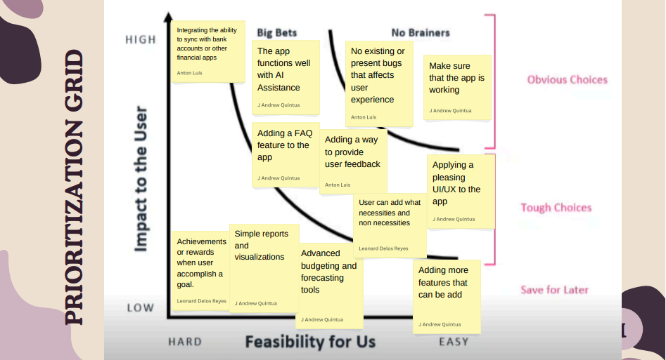

## Appendix G: As Is Map Design Thinking

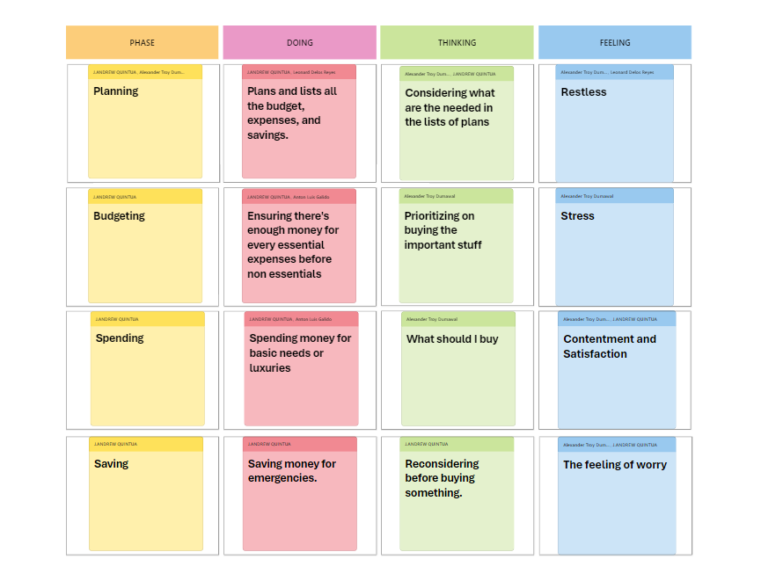

## Appendix H: Need Statement

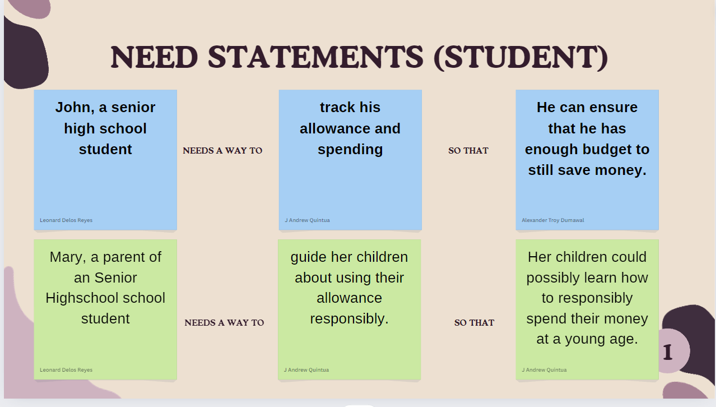

## Appendix I: Contributions

**Leonard Delos Reyes** – created the API chatbot, helped creating the UI/UX design, helped in the functions of the program

**Alexander Troy Dumawal** – created the documentations and research for the paper

**Anton Luis Galido** - created the documentations and research for the paper

**J. Andrew Quintua** – created the prototype of the UI design, contributed to the UI/UX design of the function of the program

Overall, the group demonstrated excellent collaboration and productivity, effectively contributing to the project. Each member played their part responsibly, ensuring that tasks were completed on time. There were no significant issues or conflicts that arose during the process.